Modelos no lineales: regresión segmentada

J. Ramajo

2020

library(alr4)

## Loading required package: car

## Loading required package: carData

## Loading required package: effects

## Registered S3 methods overwritten by 'lme4':  
## method from  
## cooks.distance.influence.merMod car   
## influence.merMod car   
## dfbeta.influence.merMod car   
## dfbetas.influence.merMod car

## lattice theme set by effectsTheme()  
## See ?effectsTheme for details.

plot(C ~ Temp, segreg, xlab="Temperatura media del mes (ºF)", ylab="Consumo de electricidad (KWH/día)")

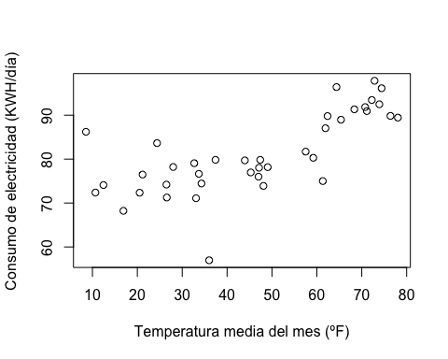

#  
segm.reg <- nls(C ~ th0 + th1 * (pmax(0, Temp - gamma)), data=segreg, start=list(th0=70, th1=.5, gamma=40))  
summary(segm.reg)

##   
## Formula: C ~ th0 + th1 * (pmax(0, Temp - gamma))  
##   
## Parameters:  
## Estimate Std. Error t value Pr(>|t|)   
## th0 74.6953 1.3433 55.607 < 2e-16 ***  
## th1 0.5674 0.1006 5.641 2.10e-06 ***  
## gamma 41.9512 4.6583 9.006 9.43e-11 ***  
## ---  
## Signif. codes: 0 '***' 0.001 '**' 0.01 '*' 0.05 '.' 0.1 ' ' 1  
##   
## Residual standard error: 5.373 on 36 degrees of freedom  
##   
## Number of iterations to convergence: 2   
## Achieved convergence tolerance: 1.673e-08

#  
plot(C ~ Temp, segreg, xlab="Temperatura media (ºF)", ylab="Consumo de electricidad (KWH/día")  
x <- (0:90)  
lines(x, predict(segm.reg, data.frame(Temp=x)))

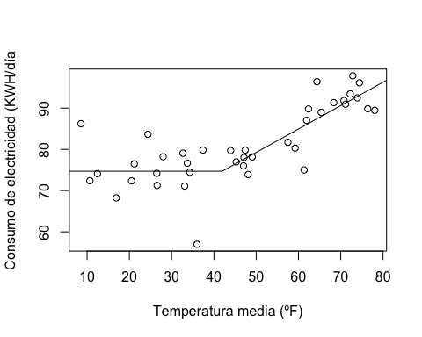

#  
segm.reg.boot <- Boot(segm.reg, R=999)

##   
## Number of bootstraps was 868 out of 999 attempted

summary(segm.reg.boot)

##   
## Number of bootstrap replications R = 868   
## original bootBias bootSE bootMed  
## th0 74.69534 0.213485 1.50020 74.88499  
## th1 0.56743 0.050539 0.12689 0.58662  
## gamma 41.95123 1.620918 4.79691 42.50541

confint(segm.reg.boot)

## Bootstrap bca confidence intervals  
##   
## 2.5 % 97.5 %  
## th0 71.1432542 77.3579542  
## th1 0.4410125 0.8000925  
## gamma 36.2487051 53.9612190

hist(segm.reg.boot, layout=c(1, 3))

